Materi 10

Machine Learning Regresi Linear dan Polinomial

Moch. Alldho Candra Ramadhan (1227030020)

Soal Nomor 1:

Modifikasi kode program contoh 3 dan diberikan Dataset X = [1,2,3,4,5,6,7,8,9,10] Y = [3,7,13,21,31,43,57,73,91,111]!

Jawaban:

|  |
| --- |
| # Nomor 1 (Dataset)  X = np.array([1, 2, 3, 4, 5, 6, 7, 8, 9, 10]).  Y = np.array([3, 7, 13, 21, 31, 43, 57, 73, 91, 111]). |

Soal Nomor 2:

Bagilah dataset menjadi 80% data latih dan 20% data uji!

Jawaban:

|  |
| --- |
| # Nomor 2: Membagi dataset menjadi 80% data latih dan 20% data uji  X_train, X_test, Y_train, Y_test = train_test_split(X, Y, test_size=0.2, random_state=42) |

Soal Nomor 3:

Buat regresi linear dan regresi polynomial derajat 2 dan bandingkan Mean Squared Error (MSE)!

Jawaban:

|  |
| --- |
| # Polynomial Regression degree 2  poly = PolynomialFeatures(degree=2)  X_poly_train = poly.fit_transform(X_train)  X_poly_test = poly.transform(X_test)  poly_model = LinearRegression()  poly_model.fit(X_poly_train, Y_train)  Y_pred_poly = poly_model.predict(X_poly_test)  mse_poly = mean_squared_error(Y_test, Y_pred_poly)  # Output MSE  print("MSE Linear Regression:", mse_linear)  print("MSE Polynomial Regression Degree 2:", mse_poly)  # Visualization  plt.scatter(X, Y, color='blue', label='Data Asli')  plt.plot(X, linear_model.predict(X), color='red', label='Regresi Linear')  plt.plot(X, poly_model.predict(poly.transform(X)), color='green', label='Regresi Polynomial Derajat 2')  plt.xlabel('X')  plt.ylabel('Y')  plt.legend()  plt.title('Regresi Linear dan Polynomial')  plt.show() |

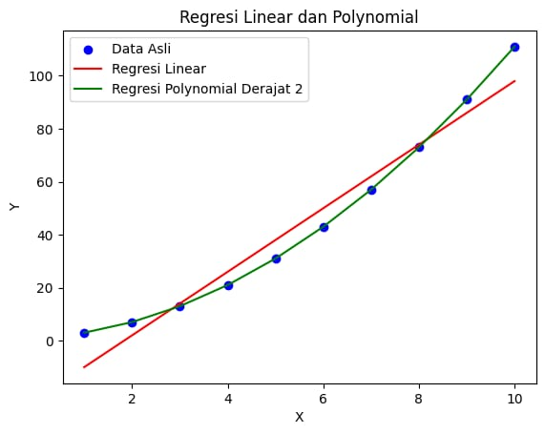

MSE Linear Regression: 25.000000000000053

MSE Polynomial Regression Degree 2: 4.35845650134609e

* Perbandingan Regresi Linear dan Polynomial (Derajat 2)

Regresi Linear:

MSE lebih tinggi dibandingkan dengan regresi polynomial jika data memiliki pola non-linear, karena regresi linear hanya bisa memodelkan hubungan linear antara variabel X dan Y.

Regresi Polynomial (Derajat 2):

MSE lebih rendah karena model polynomial derajat 2 dapat menangkap pola non-linear yang lebih telti, sesuai dengan data.

Soal Nomor 4:

Visualisasikan hasil dari komputasi tersebut!

Jawaban:

|  |
| --- |
| # Nomor 4: Evaluasi Model (Mean Squared Error)  mse_linear = mean_squared_error(Y_test, linear_model.predict(X_test))  mse_poly_2 = mean_squared_error(Y_test, poly_model_2.predict(poly_features_2.transform(X_test)))  print(f"Mean Squared Error (Linear): {mse_linear:.2f}")  print(f"Mean Squared Error (Polynomial Degree 2): {mse_poly_2:.2f}")  # Visualisasi Hasil  # Prediksi untuk seluruh dataset  Y_pred_linear_all = linear_model.predict(X)  Y_pred_poly_2_all = poly_model_2.predict(poly_features_2.transform(X))  # Plot hasil  plt.figure(figsize=(10, 6))  plt.scatter(X_train, Y_train, color='blue', label='Data Latih')  plt.scatter(X_test, Y_test, color='orange', label='Data Uji')  plt.plot(X, Y_pred_linear_all, color='red', label='Regresi Linear')  plt.plot(X, Y_pred_poly_2_all, color='green', label='Regresi Polinomial Degree 2')  plt.xlabel('X')  plt.ylabel('Y')  plt.title('Regresi Linear dan Polinomial Degree 2')  plt.legend()  plt.show() |

* 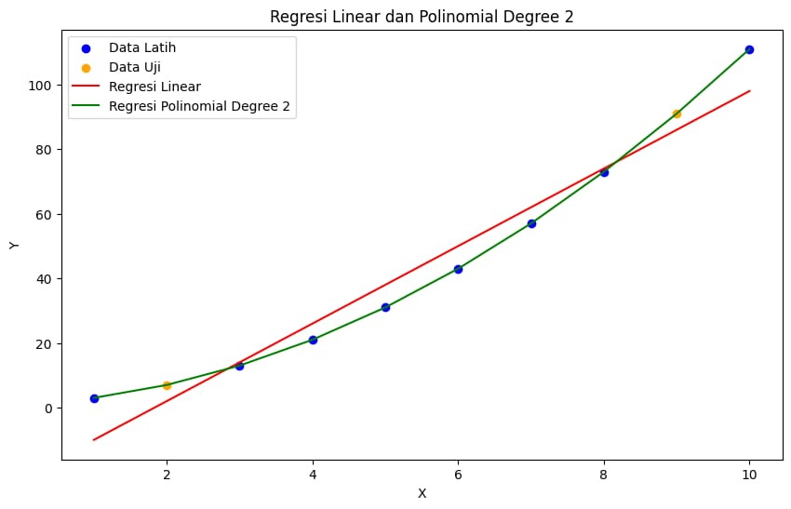Visualisasi

Mean Squared Error (Linear): 25.00

Mean Squared Error (Polynomial Degree 2): 0.00

Soal Nomor 5:

Jelaskan kode program dan gambar hasil dari soal dengan Bahasa sendiri siingkat, padat dan jelas!

Jawaban:

Kode ini membagi dataset menjadi data latih dan uji, lalu membangun dua model: regresi linear dan regresi polynomial derajat 2. Model regresi linear memprediksi hubungan garis lurus antara X dan Y, sedangkan regresi polynomial menangkap hubungan non-linear dengan menggunakan fitur polinomial. Visualisasi menunjukkan data asli, prediksi linear (garis merah), dan prediksi polynomial (garis hijau), dengan polynomial lebih akurat dalam mengikuti kurva data.

Lampiran Kode Pemrograman:

|  |
| --- |
| import numpy as np  import matplotlib.pyplot as plt  from sklearn.linear_model import LinearRegression  from sklearn.preprocessing import PolynomialFeatures  from sklearn.metrics import mean_squared_error  from sklearn.model_selection import train_test_split  np.random.seed(0)  X = [[1], [2], [3], [4], [5], [6], [7], [8], [9], [10]]  Y = [3, 7, 13, 21, 31, 43, 57, 73, 91, 111]  X_train, X_test, Y_train, Y_test = train_test_split(X, Y, test_size=0.2, random_state=42)  linear_model = LinearRegression()  linear_model.fit(X_train, Y_train)  poly_features_2 = PolynomialFeatures(degree=2)  X_train_poly_2 = poly_features_2.fit_transform(X_train)  poly_model_2 = LinearRegression()  poly_model_2.fit(X_train_poly_2, Y_train)  X_sorted = np.sort(X, axis=0)  Y_pred_linear_all = linear_model.predict(X_sorted)  Y_pred_poly_2_all = poly_model_2.predict(poly_features_2.transform(X_sorted))  mse_linear = mean_squared_error(Y_test, linear_model.predict(X_test))  mse_poly_2 = mean_squared_error(Y_test, poly_model_2.predict(poly_features_2.transform(X_test)))  print(f"Mean Squared Error (Linear): {mse_linear:.2f}")  print(f"Mean Squared Error (Polynomial Degree 2): {mse_poly_2:.2f}")  plt.figure(figsize=(10, 6))  plt.scatter(X_train, Y_train, color='blue', label='Training Data')  plt.scatter(X_test, Y_test, color='orange', label='Test Data')  plt.plot(X_sorted, Y_pred_linear_all, color='red', label='Linear Regression')  plt.plot(X_sorted, Y_pred_poly_2_all, color='green', label='Polynomial Regression (Degree 2)')  plt.xlabel('X')  plt.ylabel('Y')  plt.title('Linear and Polynomial Regression (Training & Test Data)')  plt.legend()  plt.show() |